Prepared by:
Liam Grossmann
August 2022

Energy Monitoring Web portal Development Proposal

Introduction
The purpose of this document is demonstrate my approach to delivering the Energy Monitoring Webportal (EMP). The document includes a very high level architecture as well as detailing some of the technologies I propose to use. It also includes some timelines and breaks down the project to demonstrate how the project can be successfully delivered in stages.

Background
Maria Werner has posted a job on Upwork requesting the development of an energy monitoring system. The system should be delivered as a web platform. The system will receive various messages (telemetry data ?) from measuring devices in the field. These messages should be stored in an online database and should be available for query and display using various graphical outputs including tables, charts, and histograms.

Speed, performance, throughput and scalability are critical for this system. It should be able to store and process at least 1 million messages per hour.

In addition the web portal should include a security sub-system which supports three user groups – super admin, admin and user.

Data security is important – the platform should be designed for maximum security. All transmitted data should be encrypted.

Assumptions
It should be noted that this proposal is a very early stage attempt by me to demonstrate my approach in delivering the Energy Monitoring Webportal (EMP). I would need a lot more information from the project stakeholders before we can develop and agree a project plan and technical architecture.

For example, I would need a much better understanding of the business domain – what instruments in the field are being measured, what data is coming in, how the data should be validated, aggregated and presented. I would also need a much better understanding of the data volumes involved (number of field devices, number of messages, number of users, archiving functions and so on).

High Level Architecture
I propose that the system be developed using Microsoft Azure technologies and hosted on the Microsoft Azure platform. Azure provides a very flexible way to store and process information online. Azure includes tools that help address some of the project requirements including security, data encryption, speed, performance and scalability. Azure also provides tools that will help with database archiving.

The backend code will be developed using SQL Server, C# and .NET core.

The frontend will be developed as a Single Page Application (SPA) using HTML5, java script, reactjs and some open source tools for charting and data display.
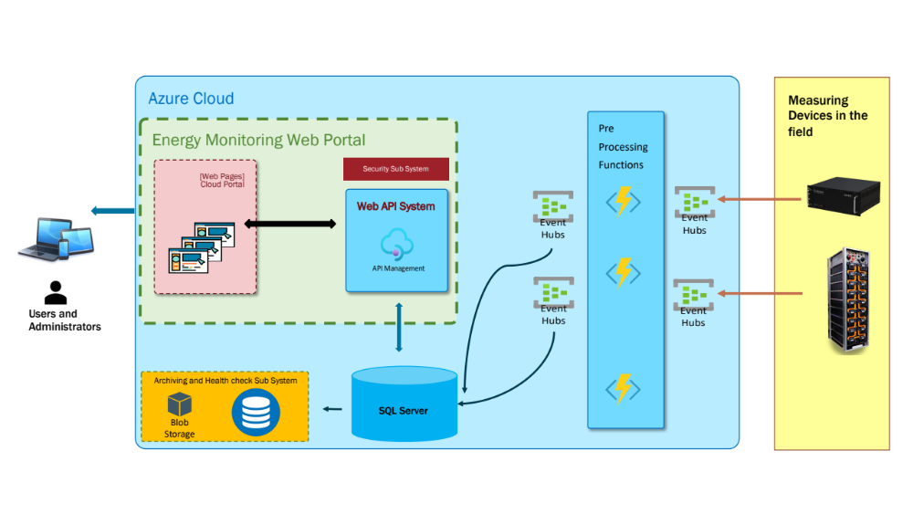
- Measuring Devices in the field send telemetry data to a series of Azure Event Hubs (message queues). These represent raw data event hubs.
- A set of pre-processing Azure functions (developed in C#) process incoming messages from the event hubs, validate them and dispatch them to another set of event hubs.
- SQL Server uses stored procedure triggers to read new events and store them in the SQL Server database.
- A set of Web APIs (developed using C#.NET core) are used to communicate and extract information from the database
- The web pages (cloud portal) is developed as a Single Page Application using HTML5, React, Java Script, ChartJS and AG Grid.
- A security sub system is used to control user access to data
- A health check and archiving sub system is used to archive data and ensure that the system remains high performant in the future.

Technical Components
The system can be broken down into four main areas follows

Messaging Subsystem
The messaging sub system will be developed using Azure Event Hubs. A series of Azure functions will be developed using C# to process the raw messages and store them in a second series of Event Hubs.

Database Subsystem
The database system will be developed using SQL Azure. SQL Azure can contain triggers which reads and processes messages directly from event hubs. The database system will also include a set of high performance stored procedures for aggregating and processing incoming data. In addition a set of stored procedures will be used to support the web api functions that the web portal will ultimately use.

Web Portal
The web portal will comprise of three parts
- Web API functions to extract data from the database
- Security Sub System
- Front End (developed as Single Page Application)

The Web API functions will be developed using C# and .NET core. These will be well tested and documented using swagger.

The security sub system will be used to control access to the web api and ultimately the data that is made available to users. Authentication and authorization will be delivered using standard .NET core infrastructure and best practices as detailed by Microsoft.

The front end will be developed as a single page application using some of the following technologies
HTLM5, CSS3
Java Script | May use type script to speed development
Bootstrap | https://getbootstrap.com/
Material Design | https://material.io/design
Chartjs | https://www.chartjs.org/docs/latest/
AG Grid | https://www.ag-grid.com/

System Health and Archiving
The system will also require an archiving solution to ensure that performance is optimized throughout the lifecycle of the system. As more and more data is stored in the system it will be necessary to archive data and perhaps store it on cheaper storage for auditing purposes.

In addition the system should contain a health check sub system to ensure that all components are running as expected. There may also be requirements to store invalid messages from the field and messages that are corrupted.

Execution Timeline

The following table details our projected execution timeline for your website development project.

Stage | Completion Date
Project Kickoff Meeting | ​
Project Design and Technical Architecture
Project Plan + Timelines
Wireframes, Mockups, Prototype
Database Design
Message Processing for 1 Device in field
Processing for most popular field devices
Processing for all field devices
Performance enhancements / scaling
System Health check and Auditing
QA Rollout / Production Rollout
Technical Documentation User Guides
Handover and Support Plan

Project Costs
There will be costs associated with hosting the system on Azure. I will be happy to incur costs using my own Azure account for the first few weeks of development. However, I will require the use of an Azure portal paid by the project stakeholder within the first 2-3 weeks of the project.

I will do my best to keep costs down and will be able to provide rough estimates of the ongoing costs as we develop the system and move into production. However, as with any cloud provider, the project stakeholder should be aware that cloud services are not cheap.

